34U ENCLOSURE 19" CABINET 600X800 FLOOR STANDING DATA RACK - ECO NETCAB
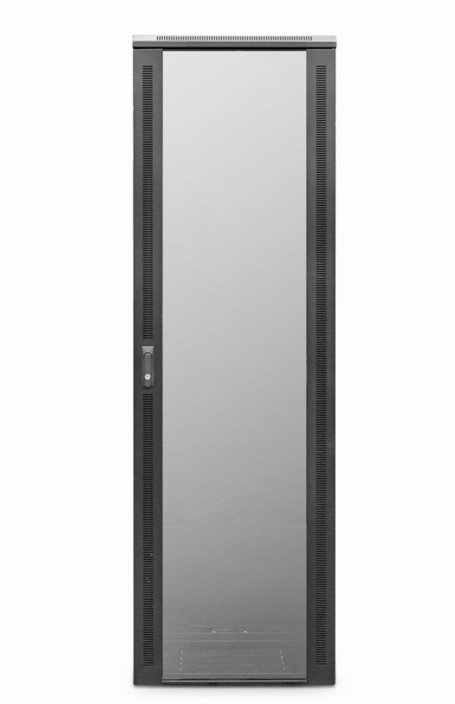

DESCRIPTION
The new CAB-FE-34U-68 is ahigh-performance, professional class enclosure with an abundance of features to help with both pre and post installation operations and of course help protect your hardware assets such as generous venting, adjustable front and rear profiles, adjustable jacking feet and HD castors as standard.
Moreover the extra 800mm depth space is ideal for larger Ethernet managed switches, rackmount UPS and even SAN or NAS devices. Broadcasting hardware will also enjoy the extra space and of course extra airflow.
As will all LMS Data EcoNetCabs in the series, bundled accessories such as installed fan tray, shelving etc are included as well as excellent ergonomics including front glass door, removable side panels and lockable rear door to house all your equipment effectively.

SPECIFICATIONS
34U high 600W 800D
- ETSI 19” front/rear adjustable profiles
- WxDxH - 600x800x1700mm (inc. castors)
- Ideal for Networking, Telco & Broadcast Applications
- Up to 800Kg static load bearing (approx)
- Front Glass door with side venting slots (lockable)
- Left/right hinged front/rear doors
- Removable side panels for easy access
- U-numbered uprights for rack-mount product alignment
- Multiple cable entry glands for exact power and cabling entry
- Fitted 4-way fan tray in raised and vented roof-space
- Fitted vented shelf
- Powder-coated RAL 9005 finish

TECHNICAL INFO
SKU/MPN: CAB-FE-34U-68
EAN: 8400800027153
Weight: 90kg
Dimensions: 600(width) x800(depth) x1690mm(height)

FILES
Datasheet - CAB-FE-34U-68

